BOY SCOUTS TROOP 1
ORELAND

T
roop 1 is one of the oldest boy scout troops in the state, close to celebrating its centennial anniversary. Based in Oreland, PA, the troop hosts scouts from Oreland, Flourtown, Erdenheim, Fort Washington, Maple Glen and other surrounding communities. Boys from any Cub Scout pack are welcome to join Troop 1, regardless of their background, activities, skills or abilities. In fact, Cub Scout experience is not necessary; a boy need only be 11-17 years old to join Troop 1. What binds all Scouts is an interest in having fun, making friends, participating in unique and enriching experiences and learning useful skills that will last a lifetime.
Troop 1 Fact Sheet
No fundraising, no popcorn sales.
Monday Troop Meetings (7:30-9PM). ALL CUPS ARE INVITED TO PARTICIPATE.
Twenty-eight active Boy Scouts with four Active Patrols (Beaver, Cobra, Fox and Hawk)
Scoutmaster (Eagle) with 45+ years of experience and 15 Assistant Scoutmasters with many years of scouting experience.
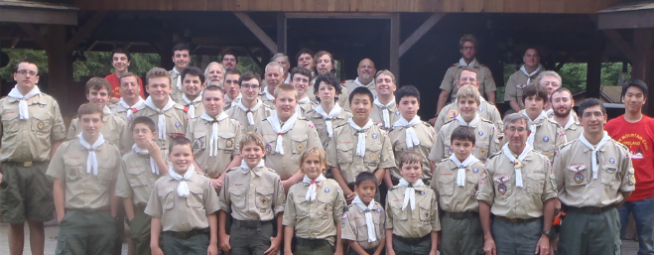
Troop celebrated its 98Th Anniversary (Founded in 1917).
Over 106 Eagle Scouts and Alumni.
Emphasis on traditional Scouting Values with active community involvement.
Troop 1 privately owns Hawk Mountain campsite.
Hawk Mountain Summer Camp is run by Troop leadership and costs less than half the cost of other summer programs.
Monthly fun-filled activities near PA camp/hiking grounds.
Troop has a strong advancement program and excellent Eagle Scout success rate.
Yearly Canoe Trip (40 miles) and Indoor Rock Climbing.
Yearly “Commando” (Capture the Flag) Weekend with three Troops and Leaders.

Troop 1 Invites Pack 173 Cub Scouts and Parents to these Upcoming Events:

- Rocket into Scouting: September 30th at Hope Lodge. ALL ARE INVITED.
- Winter Camp: January 29th-31st at Hawk Mountain Camp. Stay overnight or spend Saturday and go home at night. ALL ARE INVITED.
- Indoor Rock Climbing: February 12th at the Doylestown Rock Gym. WEBELOS INVITED.
. What binds all Scouts is an interest in having fun, making friends, participating in unique and enriching experiences and learning useful skills that will last a lifetime.

- Parent-Son Camping Weekend: May 13th-15th at Hawk Mountain Camp. Stay overnight or spend Saturday and go home at night). ALL ARE INVITED.
- Urban Orienteering in NYC: July 15th. ALL ARE INVITED.
- Overnight First Night of Hawk Mountain Summer Camp: August 6th. WEBELOS INVITED.

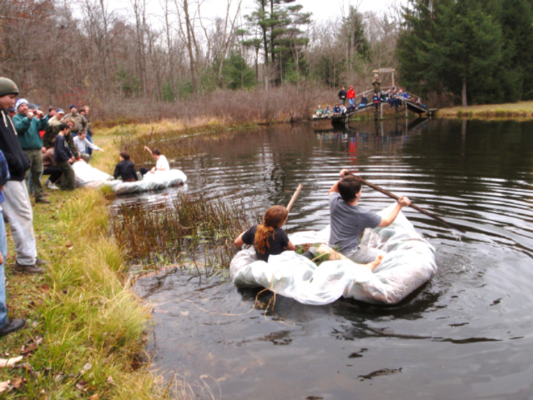
Fun, Active Boy Scout Troop!!
Water race using scout skills

A
ll alumni say Troop 1 Oreland PA offers a great scouting experience with many memorable camping trips, fire building, competing in T-Day at summer camp, going on high adventure trips to Philmont in New Mexico. Scouts learn life skills from adult leaders and older Scouts and in turn, teach younger Scouts and being part of such a wonderful organization. Wherever life takes these young men will sure to remember the principles Scouting.

